**Time Series Analysis and Modelling**

**Session-1**

# **Time Series Definition**

A Time series is a collection of observations of well-defined data items collected at different points of time.

Time series forecasting involves making projections or forecasts about future performance on the basis of historical and current data.

There are two main goals of time series analysis:

1. **Identifying the nature of the phenomenon** represented by the sequence of observations, and
2. **Forecasting** – Forecasting means predicting the future values of a time series variable.  
   Both these goals require that the pattern of observed time series data is identified. Once the pattern is established, we can interpret and integrate it with other data (i.e., use it in our theory of the investigated phenomenon, e.g., seasonal commodity prices).

# **Components of Time Series Data**

In general, there are four types of components in time series analysis:

* **Trend:** a long-term monotonic change of the average level of the time series.
* **Cyclical Component :** a long wave in the time series with cycles greater than one year.
* **Seasonal Component:** fluctuations in time series that recur during specific time periods.
* **Residual component** that represents all the influences on the time series that are not explained by the other three components

Following is the equation for a **Additive Time Series** :

Xt = St + Tt + Ct + I

Following is the equation for a **Multiplicative Time Series** :

Xt = St . Tt. Ct . I

* Additive Time series is mostly used when the data is simple and has a linear trend.

Multiplicative Time Series is mostly used in case of a complex series having mixed composite signals that may exhibit non-linearity.

* The first three components **(S,C,T)** are deterministic and they are called "Signals"
* The last component **(I)** is a purely random variable also called "White Noise". White noise cannot be predicted as it is purely random. The best way to predict white noise is to take a mean of the series.

**Trend component**

The trend is the long term pattern of a time series. A trend can be positive or negative depending on whether the time series exhibits an increasing long term pattern or a decreasing long term pattern. If a time series does not show an increasing or decreasing pattern then the series is stationary in the mean. Eg. Increase in population, large scale shift in consumer demands

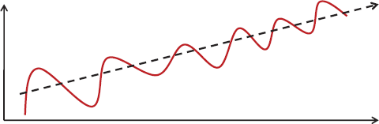

**Seasonal component**

Seasonality occurs when the time series exhibits regular fluctuations during the same month (or months) every year, or during the same quarter every year. For instance, retail sales peak during the month of December.

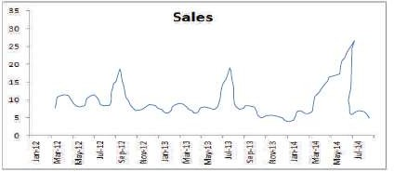

**Cyclical component**

Any pattern showing an up and down movement around a given trend is identified as a cyclical pattern. The duration of a cycle depends on the type of business or industry being analyzed. However, a typical cycle is greater than one year.

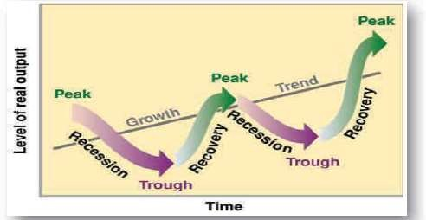

**Irregular component**

This component is unpredictable. Every time series has some unpredictable component that makes it a random variable. In prediction, the objective is to \model" all the components to the point that the only component that remains unexplained is the random component.

# **Decomposition and Re-composition**

To be able to make a proper forecast, we must know to what extent each component is present in the data. Hence, to understand and measure these components, the forecast procedure involves initially removing the component effects from the data (decomposition). After the effects are measured, making a forecast involves putting back the components on forecast estimates (recomposition).

# **Preprocessing Techniques of Time Series Data:**

## **Smoothing Methods**

* Smoothing techniques are used to remove random variation (noise) from our historical time series data.
* This allows us to better identify data patterns that are primarily trend and seasonality and using these trend and seasonality estimates we can get data levels that can be used to forecast the future data points.

There are two distinct groups of smoothing methods: ***Averaging Methods***and ***Smoothing Methods***.

## **Averaging Methods**

1. **Simple Moving Average**

The method of simple moving averages smoothes out random fluctuations of data. This method is best used for short-term forecasts in the absence of seasonal or cyclical variations. On the other hand, this method is not particularly good in situations where the series has a trend. The forecast for the value of Y at time t+1 that is made at time t equals the simple average of the most recent m observations:



“Y-hat” – forec ast of the time series at time t+1

The "simple" average or mean of all past observations is only a useful estimate for forecasting when there are no trends. The average "weighs" all past observations equally. In general:

xbar = (1/n)*SUM[i=1 to n]x(i) =
 (1/n)*x1 + (1/n)*x2 + ... + (1/n)*Xn

The (1/n) are the weights associated with each value of *x*. As we can see , these weights are normalized and sum upto 1.

1. **Weighted Moving Averages (WMA)**

* This method is also best used for short-term forecasts in the absence of seasonal or cyclical variations.
* Weighted Moving Average forecast is computed as the weighted average of the most recent k-observations where the most recent observation has the highest weight.

*Weighted MA(m) = w1.Yt + w2.Yt-1 + w3.Yt-2 + . ….* *Wm.Yt-m where:*

*Yt is the actual value of the dependent variable for period t m is the number of time periods included in the average*

**Advantages**

* It is easy to learn and apply.
* It has a relatively low computational cost.
* It can produce accurate forecasts.
* It produces forecasts quickly.
* It responds more rapidly to changes in the pattern.
* It can produce more accurate forecasts than a SMA model if applied to a trended series.

**Disadvantages**

* It fails to produce accurate forecasts if the data has cyclical or sea sonal variations.

The actual data values have to be multiplied by some weights and this makes calculations more difficult.

***Smoothing Methods***

1. **Exponential Smoothing Method**

Forecasts produced using exponential smoothing methods are weighted averages of past observations, with the weights decaying exponentially as the observations get older. In other words, the more recent the observation the higher the associated weight. This framework generates reliable forecasts quickly and for a wide spectrum of time series which is a great advantage and of major importance to applications in industry.

Exponential smoothing methods are averaging methods (in fact, exponential smoothing is a short name for an exponentially weighted moving average) that require only three pieces of data: the forecast for the most recent time period (Ft), the actual value for that time period (Yt) and the value of the smoothing constant (denoted by ).

**2. Simple Exponential Smoothing**

Simple exponential smoothing (usually referred to as exponential smoothing) is a time series forecasting method that smoothes out random fluctuations of data. It is best used for short- term forecasts in the absence of seasonal or cyclical variations. Similarly, the method does not work very well if the series has a trend.

**3**. **Holt’s Trend Exponential Smoothing**

Holt (1957) extended simple exponential smoothing to allow forecasting of data with a trend. This method involves a forecast equation and two smoothing equations (one for the level and one for the trend):

The model: Separate smoothing equations for level and trend

Level Equation :

Lt = a(Current Value) + (1 - a) (Level + Trend Adjustment)t-1

Lt = aYt + (1 - a) (Lt-1 + bt-1)

Trend Equation :

Tt = β (Lt - Lt-1) + (1 - β) bt-1 Forecasting Equation : Ft+h = Lt + h bt

Where:

L*t* denotes an estimate of the level of the series at time *t*

*bt* denotes an estimate of the trend (slope) of the series at time *t α* is the smoothing parameter for the level, 0<*α*<1

*β* is the smoothing parameter for the trend, 0<*β*<1

**4. Holt-Winters Methods**

Holt-Winters method is an exponential smoothing approach for handling SEASONAL data. In some time series, seasonal variation is so strong it obscures any trends or cycles, which are very important for the understanding of the process being observed. Winter ’s smoothing method can remove seasonality and makes long term fluctuations in the series stand out more clearly.

Two Holt-Winters methods are designed for time series that exhibit linear trend :

* Additive Holt-Winters method : used for time series with constant (additive) seasonal variations.
* Multiplicative Holt-Winters method : used for time series with increasing (multiplicative) seasonal variations.

The multiplicative Holt-Winters method is the better known of the two methods.

**Advantages**

* Used for short term forecast
* Gives interpretable results
* Easy to implement

Being able to adapt to changes in trends and seasonal patterns

**Disadvantages**

* Presence of outliers distorts the results
* Can’t generalize to multivariate approach
* Accounts for only single seasonal pattern
* Holt’s only forecasts the past information of the forecasting variable

**Identification of Time Series Patterns:**

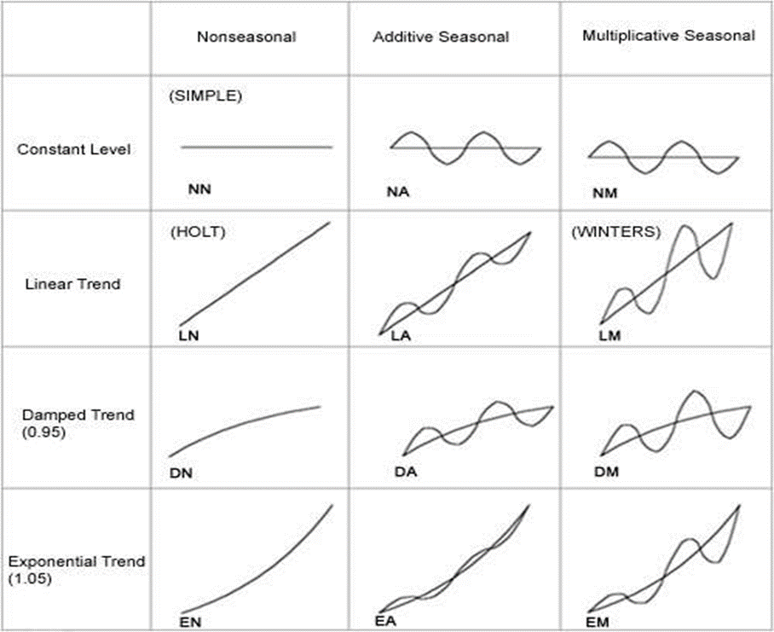

**Smoothing Methods applied based on nature of data:**

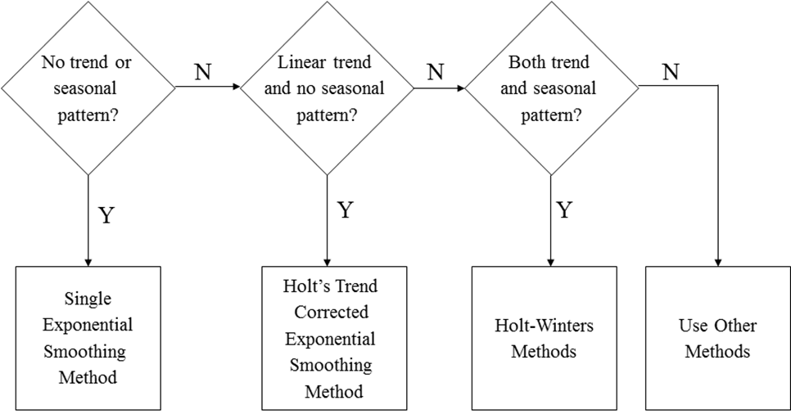

# **Measuring Forecast Accuracy**

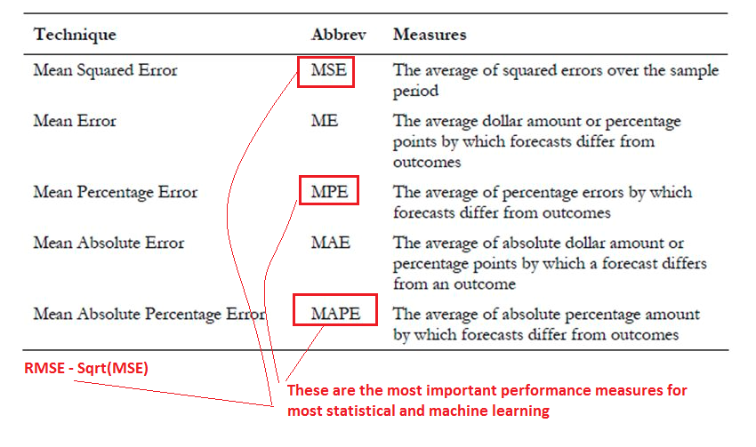

# **Working Examples**

<https://github.com/bhaskatripathi/Timeseriesbasics>